Village of Nassau
Shred Day

October 15th is

40 Malden Street
Nassau, NY
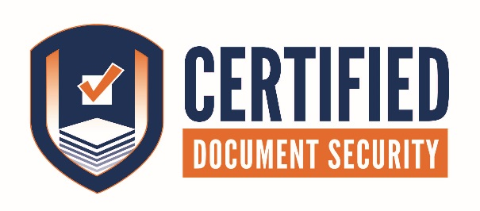
&

OPEN TO THE PUBLIC
Come join us on October 15th!!!
Bring us your old documents and personal papers. The locked containers will be set up from 9am-12pm, for your documents. Drop off three bags or boxes for free!!
After the event, Certified Document Security will take the documents back to our secure shredding facility and shred it all. After we shred the combined paper, 1,500 pound bales get sent to a recycle plant and turned into paper towels, toilet paper, etc. Our secure system allows for your paper to be locked down until it is mixed with hundreds of other documents from multiple sources, then recycled.
If you have questions about our company, please call Certified at: (518) 766-9607.
Items to consider shredding for your safety and privacy:
- Address labels from junk mail
- ATM recipes
- Bank statements
- Birth certificate copies
- Canceled or voided checks
- Credit and charge card bills, carbon copies, summaries and receipts
- Credit reports and histories
- Employee pay stubs
- Expired credit and identification cards, including driver’s licenses, college IDs, military IDs, employee badges, medical insurance cards, etc.
- Expired passports and visas
- Legal documents
- Insurance documents
- Investment, stock and property transactions
- Luggage tags
- Medical and dental records
- Papers with a Social Security number
- Pre-approved credit card applications
- Receipts with checking account numbers
- Report cards
- Resumes or curriculum vitae
- Signatures (ex. leases, contracts, letters)
- Tax forms
- Transcripts
- Travel itineraries
- Used airline tickets
- Utility bills (ex. telephone, gas, electric, water, cable TV, internet

