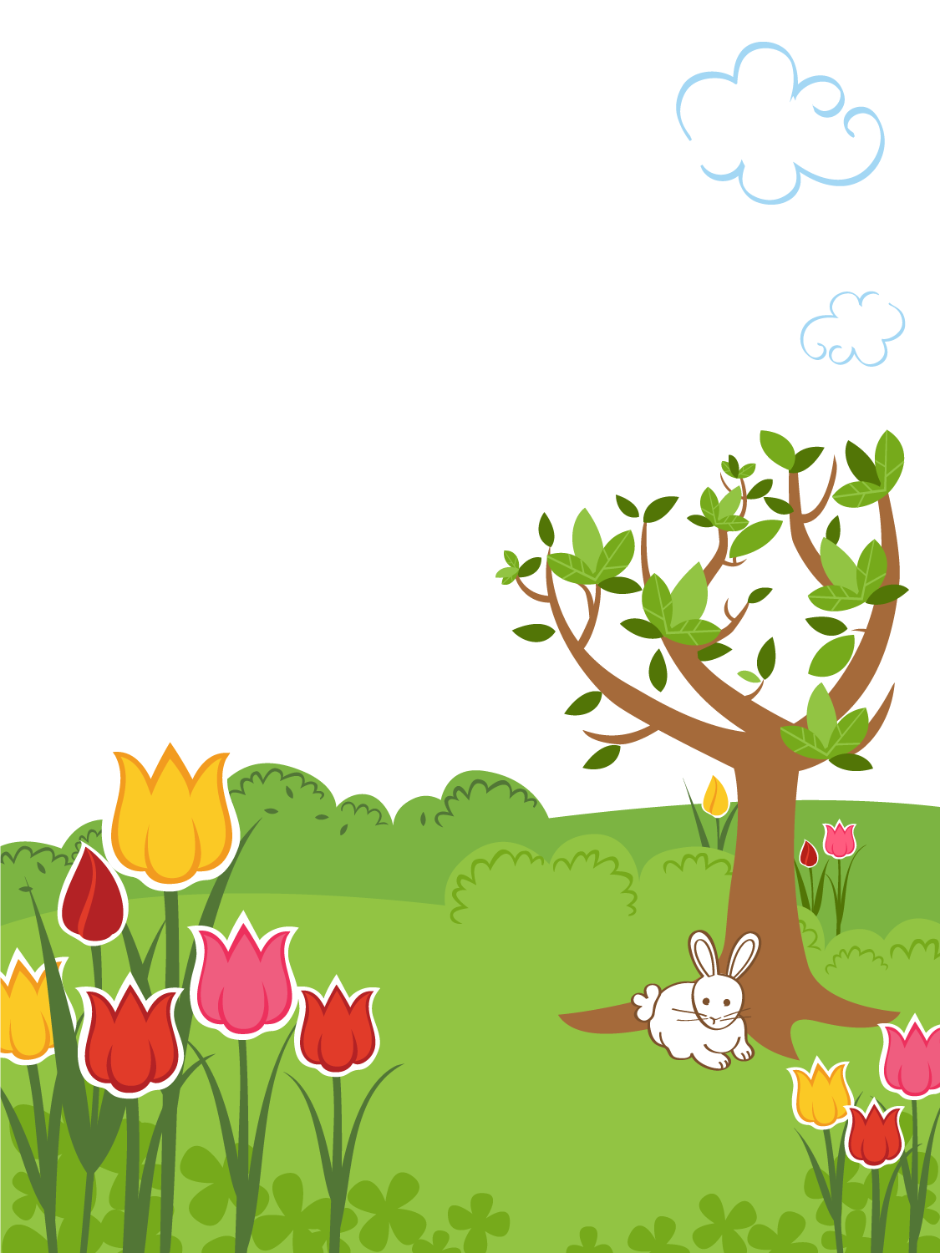
Easter Egg Hunt
Saturday, April 13
Village Commons
John St.
11AM

Visit from the Easter Bunny
Lots of candy-filled eggs
Sponsored by the Village Youth Committee
For more information, call
Judy at 518-522-2916

